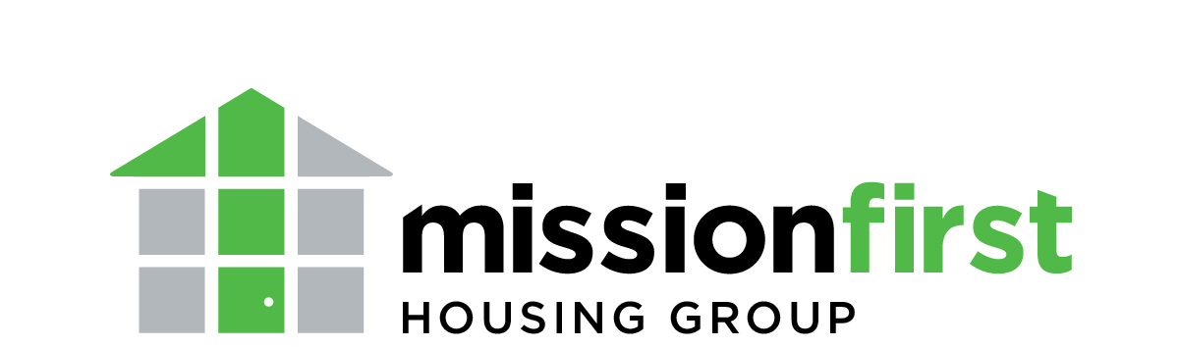
Welcome Home 2026
Event Sponsorship Form

Contact Name: _______________________________________________________________
Company: ___________________________________________________________________
Address: ____________________________________________________________________
____________________________________________________________________
Phone number: _______________________________________________________________
Email address: _______________________________________________________________
Sponsorship Level:
□ Platinum Sponsor - $20,000 – Limit One
□ Titanium Sponsor - $17,500
□ Gold Sponsor - $15,000
□ Silver Sponsor - $12,500
□ Bronze Sponsor - $10,000
□ Affordable Housing Champion - $6,500
□ Partner Sponsor - $3,000
□ Contributor Sponsor - $1,500
□ Friend Sponsor - $750

Specialty Sponsorships (Limit one. Please call to confirm availability.)
□ Video Sponsor - $10,000
□ Drink Sponsor - $7,500
□ Registration Sponsor - $6,000
□ Dessert Sponsor - $5,000
□ Entertainment Sponsor - $4,000
□ Decor Sponsor - $3,000

Payment type:
□ Cash □ Check
□ Credit Card (Complete transaction at www.missionfirsthousing.org/welcomehomesponsorships or call to process over the phone.)
□ Invoice requested

Please send completed form along with payment to:
Attn: Becky Lang Staffieri, Welcome Home event
Mission First Housing Group
2042-48 Arch Street, 2nd Floor
Philadelphia, PA 19103

You will receive an email receipt once your information is processed. If you have any additional questions, please contact Becky at (215) 651-4858 or rstaffieri@missionfirsthousing.org.

