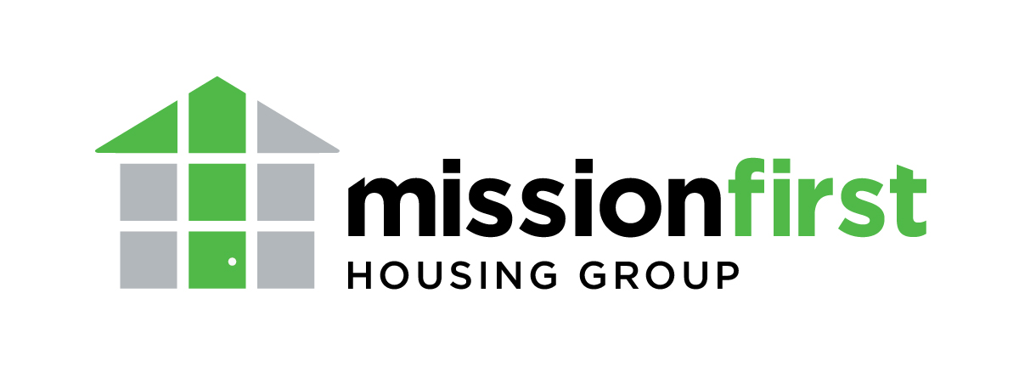
Building Home
Event Sponsorship Form

Contact Name: _______________________________________________________________
Company: ___________________________________________________________________
Address: ____________________________________________________________________
____________________________________________________________________
Phone number: _______________________________________________________________
Email address: _______________________________________________________________
Sponsorship Level:
□ Platinum Sponsor - $10,000 (Limit one. Please call to confirm availability.)
□ Gold Sponsor - $7,500
□ Silver Sponsor - $5,000
□ Bronze Sponsor - $3,750
□ Affordable Housing Champion - $2,500
□ Partner Sponsor - $1,500
□ Contributor Sponsor - $750
□ Friend Sponsor - $250

Specialty Sponsorships (Limit one. Please call to confirm availability.)
□ Drink Sponsor - $3,000
□ Registration Sponsor - $3,000
□ Dessert Sponsor - $2,500
□ Entertainment Sponsor - $2,000
□ Decor Sponsor - $1,500

Payment type:
□ Cash □ Check
□ Credit Card (Complete transaction at www.missionfirsthousing.org/buildinghomesponsorships or call to process over the phone.)
□ Invoice requested

Please send completed form along with payment to:
Attn: Becky Lang Staffieri, Building Home event
Mission First Housing Group
2042-48 Arch Street, 2nd Floor
Philadelphia, PA 19103

You will receive an email receipt once your information is processed. If you have any additional questions, please contact Becky at (215) 651-4858 or rstaffieri@missionfirsthousing.org.

