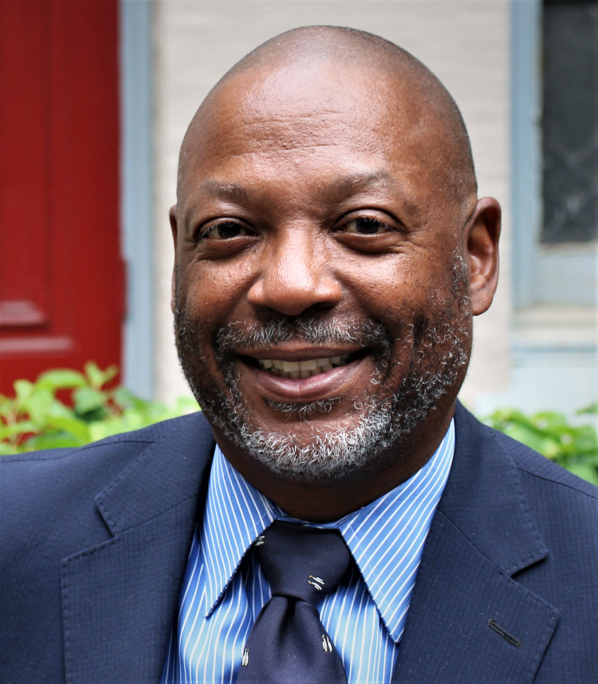
Thomas A. K. Queenan
Chief Executive Officer

Thomas Queenan joined Mission First Housing Group in June 2022 as its new Chief Executive Officer. Mission First is a nonprofit affordable housing company that provides safe, affordable, sustainable homes to nearly 6,200 people in over 4,200 apartments. Founded in Philadelphia in 1989, our footprint now encompasses the Mid-Atlantic region where we serve a diverse resident population that includes families, seniors, veterans, survivors of domestic violence, nearly 1,000 formerly homeless individuals and families and persons with disabilities. Mission First develops, constructs, and manages our properties that provide supportive services to our many residents.

Thomas reports to the Board of Directors and works collaboratively with Executive and Director-level staff members in each of Mission First’s business lines (development, construction, property management and resident services) and shared services to oversee, develop and implement the strategic plan, ensuring the organization consistently achieves its mission and financial objectives. He ensures the organization manages growth effectively; assuring financial strength while advancing the mission and builds the organization’s external identity in order to promote visibility, preserve and expand resources and connect with other professionals and organizations.

Prior to joining Mission First, Thomas served as Executive Vice President and Chief Operating Officer of Philadelphia Industrial Development Corporation (PIDC). During his tenure at PIDC, Thomas was responsible for overseeing finance, financial reporting, accounting, and business operations, including IT and Data Management, Human Resources, Facilities and the Office of General Counsel. His work at PIDC was built on more than 30 years of diverse finance, and business operations experience, including CFO of the Milton Hershey School and Trust, VP Finance and Operations at Dickinson College, head of treasury operations at Temple University Health System and former City Treasurer during the Rendell Administration.

Thomas is a Philadelphia native. He is a graduate of Syracuse University with a bachelor’s degree in architecture. He also has a master’s degree in architecture and city planning from Columbia University and an MBA from The Wharton School, University of Pennsylvania. Thomas practiced health care architecture for 10 years and remains a registered architect in the Commonwealth of Pennsylvania.

